Using .NET Core 3.1

I have added 3 projects - Console App, MVC App and a test project. To run Console App or MVC, right click on the project file and set it as a start up project. Decided on MVC application is there is separation of concern and testing could be implemented easily.

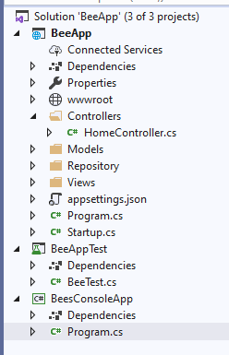

10 Bees of each type are added and damage() method is applied with random numbers. Console App output is displayed as below:

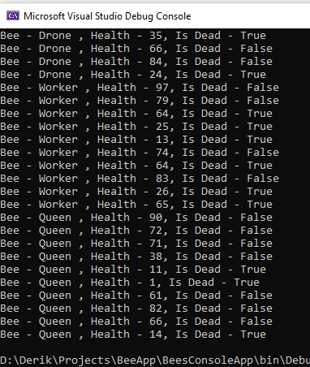

Damage button is clicked and output is displayed below each bee. If health goes below 0, its reset to 0. And no more damage is applied to that bee.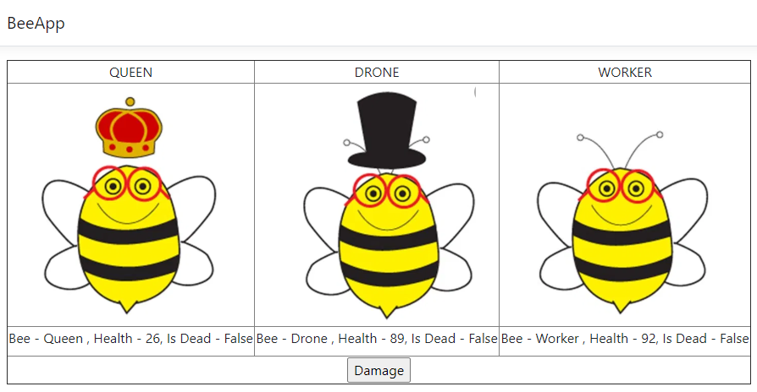

Have added a test project for some cases of the bee.

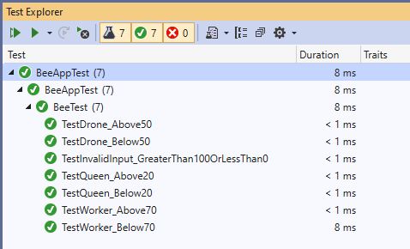

Some properties I have set as below with comments

